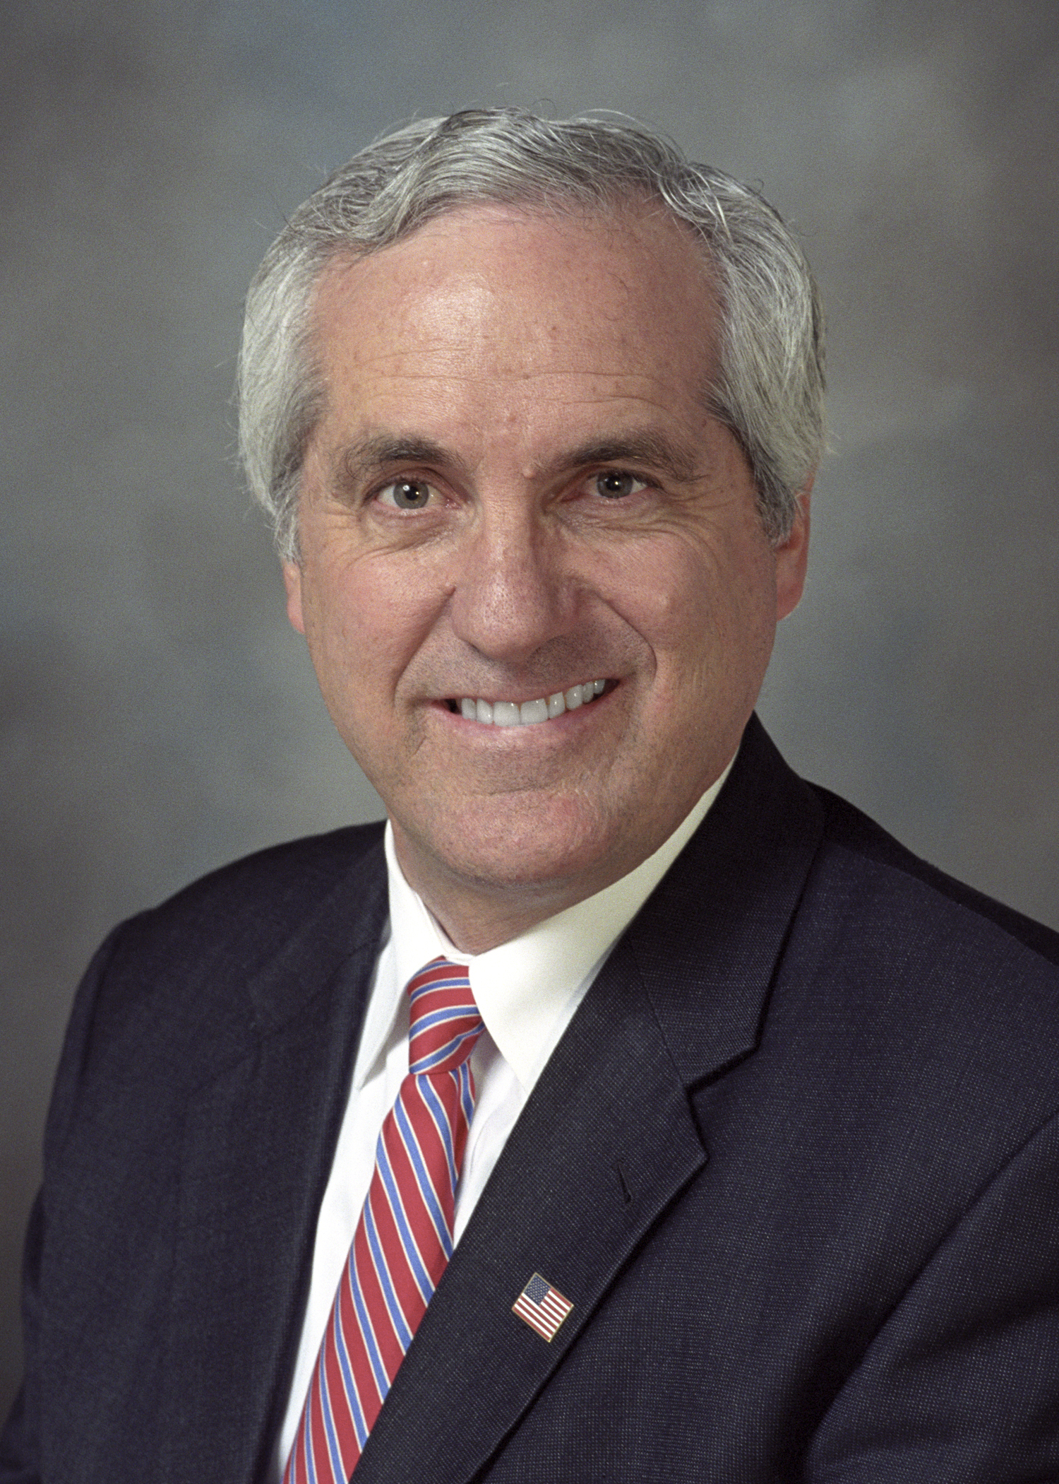 | Senator Eliot Shapleigh  District 29  Press Advisory  Contact:  Daniel Collins  (915) 544-1990  daniel.collins@senate.state.tx.us | 

For Immediate Release
February 13, 2009
City leaders travel state capitol for
El Paso Days in Austin
"El Paso Days is Austin is our chance to tell the El Paso story,
to advocate for our children, our community and our future"
****************

EL PASO – On Tuesday, February 17 and Wednesday, February 18, 2009, El Paso civic and business leaders will travel to Austin, Texas for El Paso Days in Austin. Each legislative session, El Paso leaders meet with state legislators and representatives from state agencies to discuss the city's needs for this legislative session.

Over the two days, visitors to Austin will meet with Senator Shapleigh and all five members of the El Paso House delegation, and special resolutions will be read commemorating El Paso Days on both the House and Senate floors. Visitors will also meet with Governor Rick Perry, Lieutenant Governor David Dewhurst and Speaker of the House Joe Straus. Senator Shapleigh will host a reception Wednesday in the Lieutenant Governor's Conference Room, adjacent to the Senate floor.

"El Paso Days is Austin is our chance to tell the El Paso story, to advocate for our children, our community and our future," Senator Shapleigh said.

Visitors to Austin will also meet with representatives from state agencies such as the Texas Health and Human Services Commission and the Texas Department of Transportation.

El Paso Days in Austin is annually organized by the Greater El Paso Chamber of Commerce.

- More -

The Chamber expects this El Paso Days to be the largest trip ever organized, with more than 50 confirmed attendees. Visitors include representatives of El Paso city and county government; the University of Texas at El Paso, El Paso Community College, and the Texas Tech Health Sciences Center in El Paso, Fort Bliss, the El Paso Regional Economic Development Corporation (REDCo), and other representatives of El Paso's health and business communities.

For more information on El Paso Days in Austin, please contact the Greater El Paso Chamber of Commerce at 915-534-0500.

-End-

